|  |  |
| --- | --- |
| Course Name | ITD 2313 – Script Programming |
| Instructor | Morris |
| Student Name | John |
| Due date | 01/15/2023 |
| Grade | Put grade earned here |
| Grading Comments | Put instructor comments here |

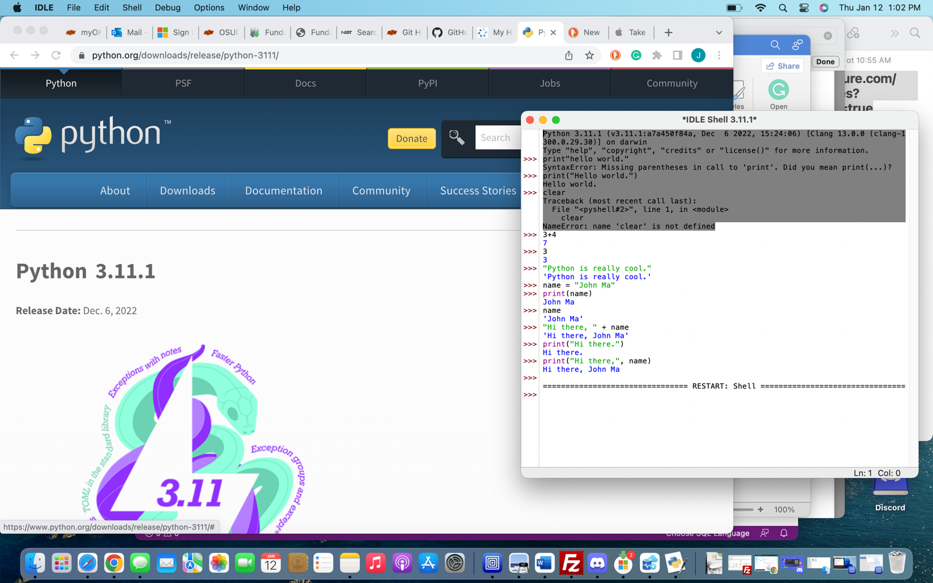

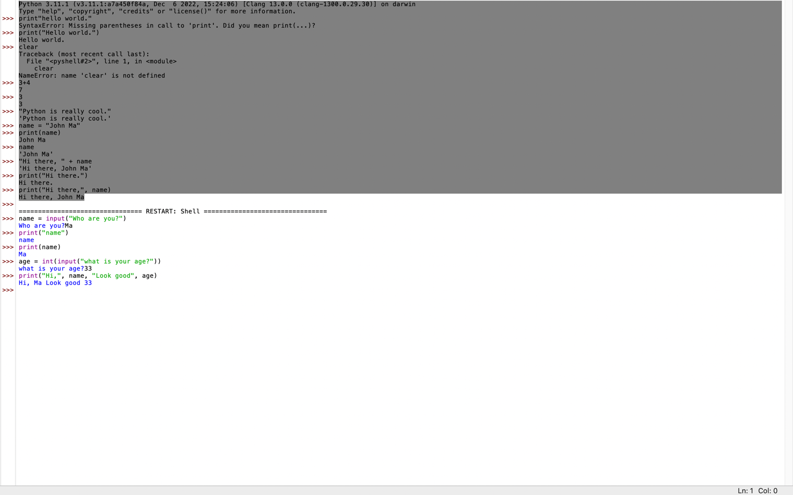

P-26

